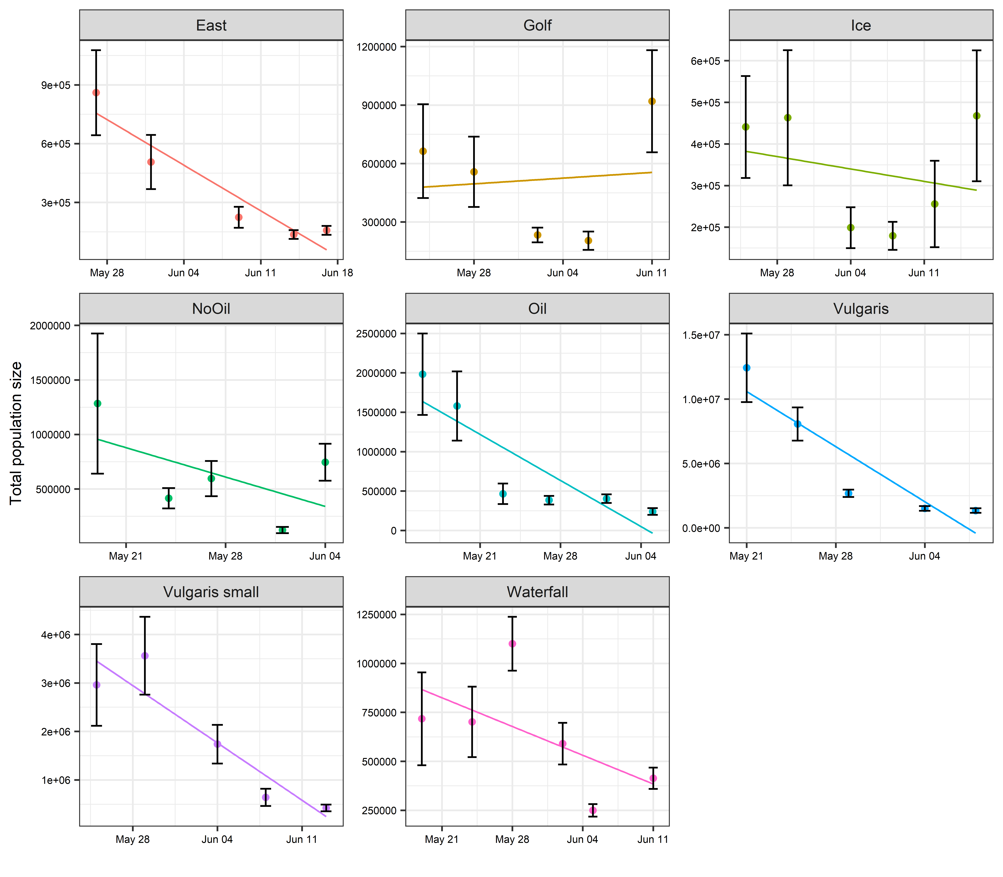

Total population size in each pond over the immature lifespan (+/- standard error). First date = after all mosquitoes had hatched. Last date = last date before mosquitoes began emerging.

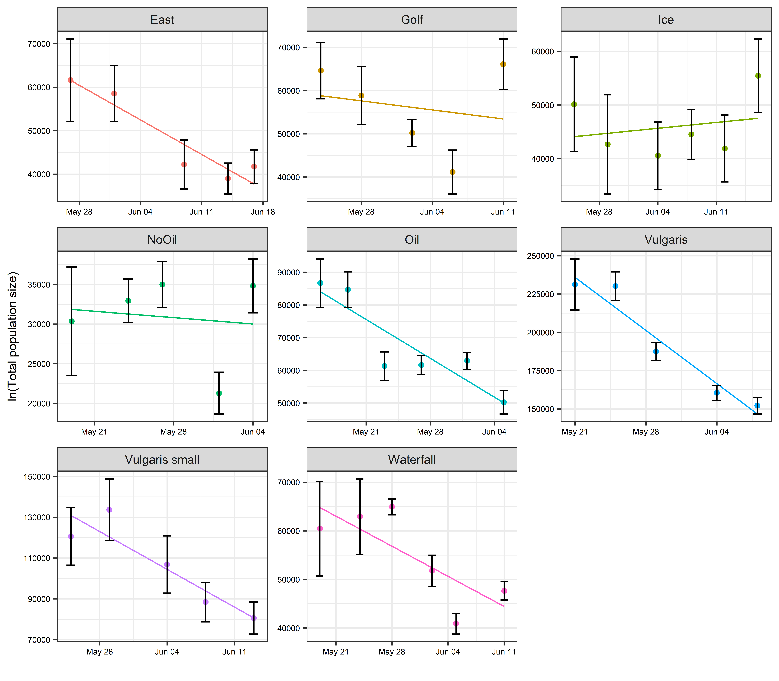

Same as previous graph, but not It is the ln(N) on y. Line represents per-capita mortality over immature period.

Abundance is highly aggregated

* + Average variance to mean ratio (VMR) across all ponds and dates = 67456
  + For all ponds, VMR declines over time. Initial dispersion is highly aggregated, becoming less aggregated over time
  + *Standard error estimates assume a poisson distribution (random dispersion), so our standard error are approximate

Per capita mortality rates: Slopes from the lines in figure 2

Site slope

*<fct>* *<dbl>*

1 East -1136

2 Golf - 298

3 Ice 156

4 NoOil - 114

5 Oil -1697

6 Vulgaris -4964

7 Vulgaris small -2646

8 Waterfall - 885

**Note that Ice has a positive mortality rate…

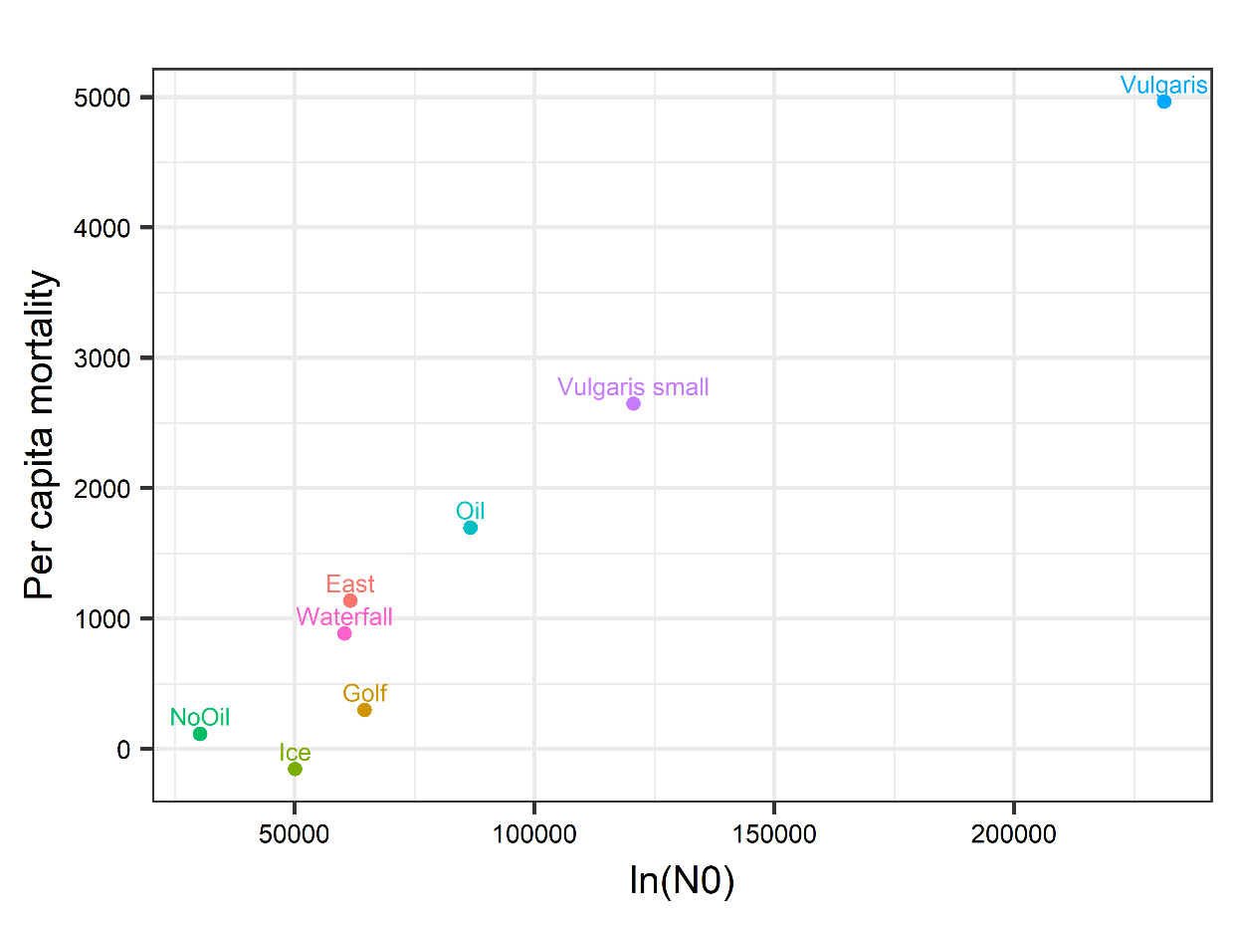

Per capita mortality rate increases with population size.

How did I calculate total pond population and standard error.

**Data file: larvalcounts_2018_11_28.xlsx**

**R file: Totalpopestimates_11_28_2018.R**

**Also see**: **Populationsizeequations11_2018.xlsx**

* Total pond population = Average number/sample * # of potential samples in a littoral area
* Littoral area = Pond perimeter (m^2) X 1.5 m X 0.2 (average depth)
  + ***This slightly overestimates littoral area. Working on another way to calculate this, so numbers will change a bit
* Littoral area originally in m^3. Converted to Liters (1 m3 = 1000 L)
* Standard error calculation: Cochran 1977 (Equation 2.21) (uses the total area and finite population correction)